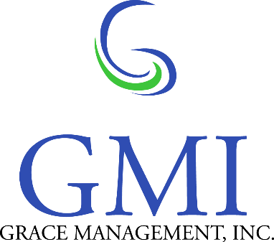

**Capable and reliable service so you can focus on your mission…**

Contact Us:

**Jennifer Chambers, President / CEO**

(503) 430-1270

jennifer@gracemgt.com

**Dennis Chambers, Corporate Secretary**

(503) 430-1270

[dennis@gracemgt.com](mailto:dennis@gracemgt.com)

**Travis Walker,**

**VP, Operations**

(843) 228-4614

travis@gracemgt.com

**Address:**

5335 Meadows Road, Suite 385

Lake Oswego, OR 97035

**Website**

www.gracemgt.com

***“Your excellent service always brightened my day!”***

**“*Without you guys, I wouldn’t have made it through.”***

***“I looked forward to chow hall every day – you guys never disappointed!”***

- Recruits from Platoon 1092, Parris Island, SC



**core competencies**

**Food Services:** Prepare, tailor, and serve high quality menus to client specifications. Contract compliance training. Customize solutions by providing fresh, diverse, and innovative products.

**Program and Project Management:** GMI offers an onsite management team totaling more than 60 years of experience in providing top quality service to our clients and customers.

**Facilities Management and Warehousing:** Teaming partners are utilized for facilities management and warehousing to provide a full line of services ensuring client satisfaction and enhancing profitability.

**Procurement Support:** As an official distributor of EcoLab products, we focus on providing only the highest quality, environmentally conscious cleaning and sanitation supplies, with competitive prices.

Established in 2008 by members of the Confederated Tribes of Siletz Indians of Oregon, GMI is a certified EDWOSB experienced in every facet of providing food services for the US Marine Corps. We have well established business partnerships with both Sodexo and EcoLab and together we have consistently proven exceptional service through our dedication to quality, customer service, environmental consciousness, contract compliance, and continued process improvement.

Native American Owned

Economically Disadvantaged Women Owned Small Business (EDWOSB)

Small Disadvantaged Business (SDB)

Minority Business Enterprise (MBE)

Disadvantaged Business Enterprise (DBE)

**DUNS**: 827029633

**CAGE Code**: 544R0

**NAICS**:

325611: Soap and other Detergent

325612: Polish and other Sanitation Good Manufacturing

493110: General Warehousing and Storage

541618: Other Management Consulting Services

561210: Facilities Support Services

561720: Janitorial Services

**722310: Food Service Contractor (Primary)**

811310: Commercial and Industrial Machinery and Equipment Repair and Maintenance

**at a glance**

**MCRD, Parris Island, SC** (April 2011 to Present)

Sub-Contract # SDXGS-11-C-0005 under Prime Contractor, Sodexo

**MCB, Camp Lejeune, NC** (July 2012 to Present)

Sub-Contract # SDXGS-11-C-0005 under Prime Contractor, Sodexo

**Experienced Management Team** possesses more than 20 years’ experience in the food service industry and decades of senior management experience with the Federal Government and Fortune 500 Companies.

**Recognized Quality of Service**: WPT Hill Memorial winner for two consecutive years in annual competition to recognize the USMC’s best food service operation worldwide.

**past performance**

**summary**